Y FENNI & DISTRICT RIDING CLUB MINI DRESSAGE D 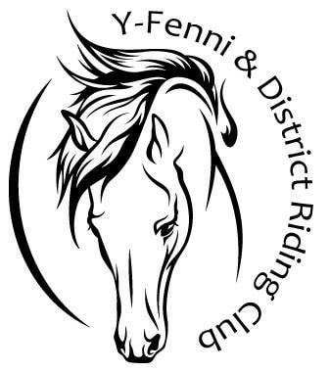

NAME OF RIDER_____________________________

NAME OF PONY_____________________________

 | MOVEMENT | MAX. MARK | JUDGES MARK | COMMENTS
1 | A Enter at walk down centre line at C turn left | 10
2 | H E K Trot | 10X2
3 | K Walk, K A F Walk | 10
4 | F X H Trot H Walk | 10x2
5 | H C M Walk | 10
6 | M B F Walk | 10
7 | A Turn down centre line  X Halt and salute | 10
 | TOTAL MARKS | 90
 | Judges name:  Signature:  Date |  |  | Judges Comments:

